Library and Information Science
University of Kashmir

Eminent Personalities visit (2019-23)
01 | Prof. Shabahat Hussain  (Former, Chairman Deptt. of LIS, AMU and Former University Librarian A.M.U) | 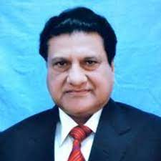 | September 6-7, 2022
02 | Prof. Jagtar Singh  (Former, Head, Department of Library and Information Science, and University Librarian, Guru Kashi University, Punjab) | 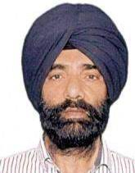 | September 6-7, 2022
03 | Dr. Kanchan Negi  (Intl. Educationist, Intl. Trainer, Research & Development, Media & Communication Expert, Social Reformer) | 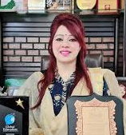 | October, 19, 2022
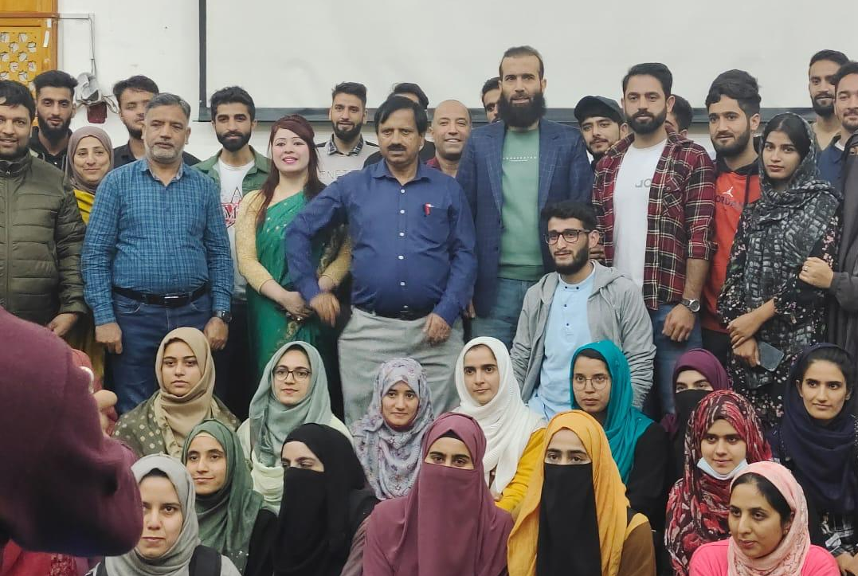
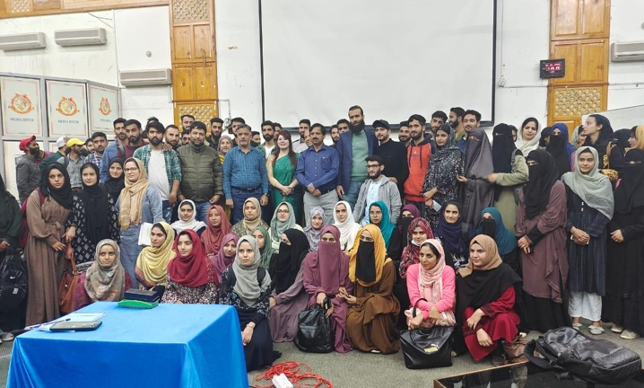
04 | Prof. M. P. Satija  (UGC Emeritus fellow, Professor of Library and Information Science, Guru Nanak Dev University Amritsar, India) | 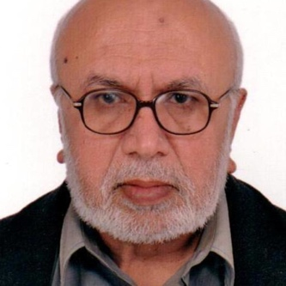
05 | Prof. Rupak Chakarburty  (Professor,  Department of Library & Information Science, Panjab University ) | 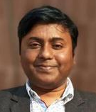
06 | Prof. M. P. Singh  (Professor and Dean School of Information Science & Technology Deptt. of LIS, Babasaheb Bhimrao Ambedkar University, Haryana) | 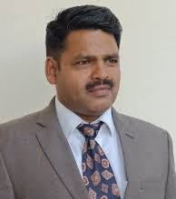 | September 6-7, 2022
07 | Prof. K. L. Mahawar  (Head, Deptt. of LIS, Babasaheb Bhimrao Ambedkar University, Haryana) | 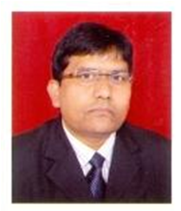
08 | Prof. Manoj Kumar Verma  (Professor & Head, Department of Library and Information Science, Mizoram University, Aizawl) | 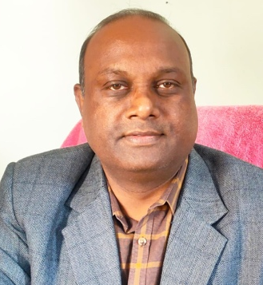 | September 6-7, 2022
09 | Prof. Sushmita Chakraborty  (Professor & former Head, Department of Library & Information Science, University of Calcutta) |  | November 16-17, 2023
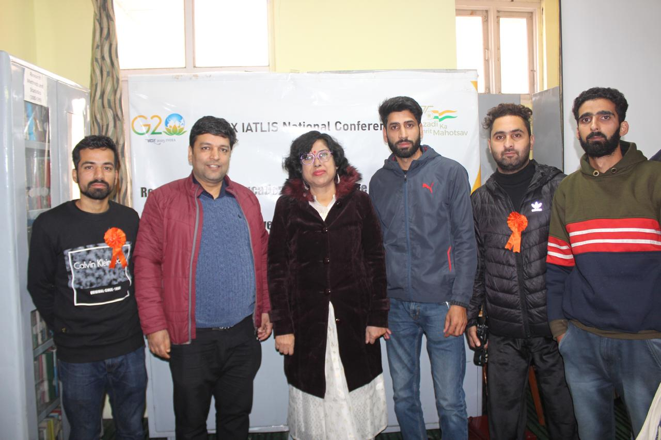
10 | Prof. Sangita Gupta  (Professor, Head and Dean, Faculty of Social Sciences, Deptt. of Library and Information Science, University of Jammu) | 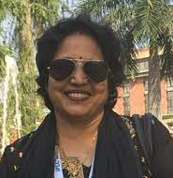 | September 6-7, 2022  &  November 16-17, 2023
11 | Prof. H. P. S. Kalra  (Professor, Department of Library and Information Science, Punjabi University, Patiala) | 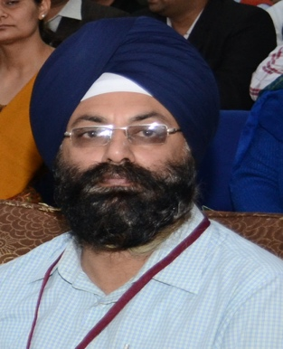 | November 16-17, 2023
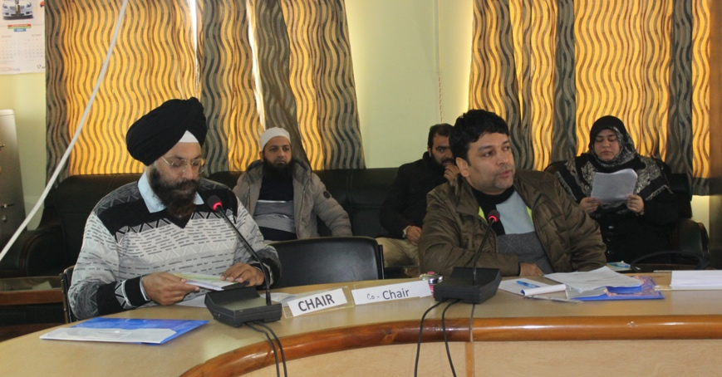
12 | Dr. Khushpreet Singh Brar  (Assistant Professor. Department of Library and Information Science. Panjab University, Chandigarh) | 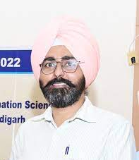 | November 16-17, 2023
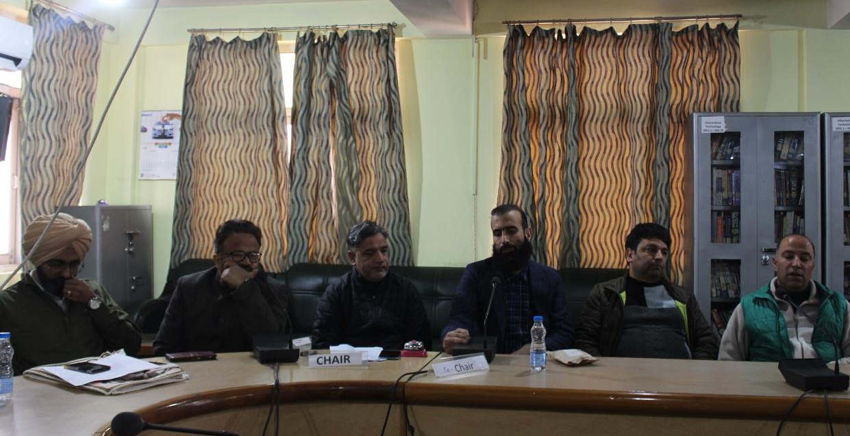
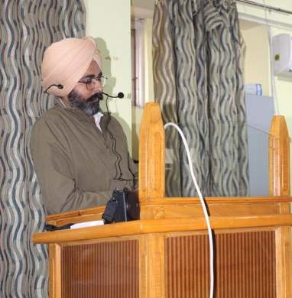
13 | Dr. Promod Kumar Singh  (Sr. Assistant Professor, Department of Library and Information Science, University of Jammu) |  | November 16-17, 2023
14 | Dr. M. Mahbubul Islam  (Associate Professor, Department of Information Science and Library Management, University of Rajshahi, Bangladesh) | 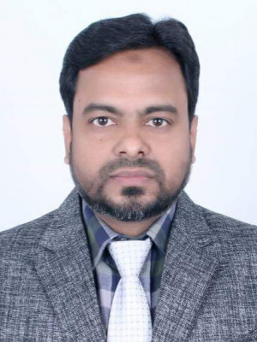
15 | Prof. M. Nazmul Hasan  (Professor, Department of Information Science and Library Management, University of Rajshahi, Bangladesh) | 